NSCC 360°

DOCUMENTATION



**MILESTONE I**

Spencer Wade

Rafael Ferraz

Tyler Corporon

Ryan Hatchard

Document Version: 1.0

Winter 2019

# THE APPLICATION

* A virtual tour of the NSCC Institute of Technology Campus using virtual reality, enabling app users to select and view 360 images of selected locations.

# THE ARCHITECTURE

The main application is divided into three different apps that communicate with each other. They are:

* A frontend that is build using NEXTJS and REACTJS. This application is responsible for displaying the information about the page, displaying the map of the campus, and any other data that appears in the frontend. This application is served through NEXTJS.
* A framework that uses REACT 360 frameworks. This app is responsible for rendering the equirectangular photos of the campus. This application communicates with the home page frontend though an iframe. This application is served though a NGINX server.
* A NGINX server that works as a router to the frontend and the REACT 360 application.

Each application is served through a docker container. The image below illustrates the flow of communication between the containers:

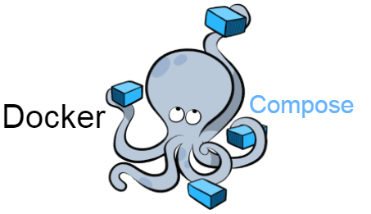

Network between containers through

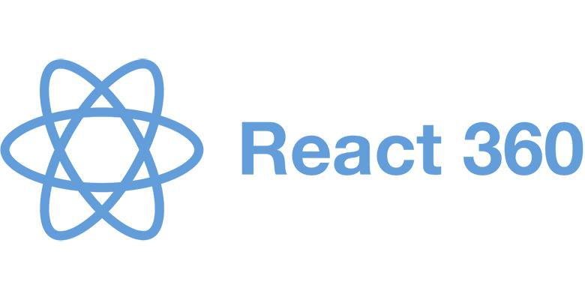

URL /vr

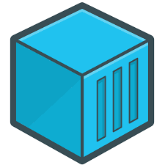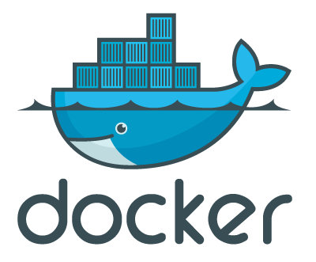

Render Equirectangular photos





Port 80



Router





URL /



Front-End

# THE FILES

The directory for the files was created based on the architecture presented above. The directory tree is illustrated below:

* frontend/

|- pages/

|- components/

|- static/

|- Dockerfile

* nginx/

|- default.conf

|- Dockerfile

* nscc360/

|- components

|- static assets

|- tour.json

|- client.js

|- index.js

|- Dockerfile

* docker-compose.yml

As showed above, each app has its own directory and its on Dockerfile that build the images that are use for docker-compose to build all the services together. The docker-compose.yml holds the configuration to setup the three services, as showed below:

services:

ngnix:

build:

dockerfile: Dockerfile

context: ./nginx

restart: always

ports:

- "80:80"

frontend:

build:

context: ./frontend

dockerfile: Dockerfile

restart: always

nscc360:

build:

context: ./nscc360

dockerfile: Dockerfile

restart: always

As noticed, the only service that expose a port is the nginx though the port 80. The network between the containers are handle by docker-compose.

The nginx that serve as a router obeys the rules stablished in the file default.conf as showed below:

upstream frontend {

server frontend:3001;

}

upstream vr {

server nscc360:3000;

}

server {

listen 80;

location / {

proxy_pass http://frontend;

proxy_set_header Host $host;

}

location /vr {

rewrite /vr/(.*) /$1 break;

proxy_pass http://vr;

proxy_set_header Host $host;

}

}

That way, if the client request a page in the / domain, the router will forward the request to the frontend server, or if /vr is requested, the request is forward to nscc360 server that serve the react 360 app.



The project is using version control using GitHub. To access the repository, please click in the link below:

<https://github.com/ferrazrx/nscc360>

THE INSTALLATION

After you clone the repository, make sure to run the commands in your command line below: 

npm i   
docker-compose up

# SCREENSHOOTS

Version 1.0.0

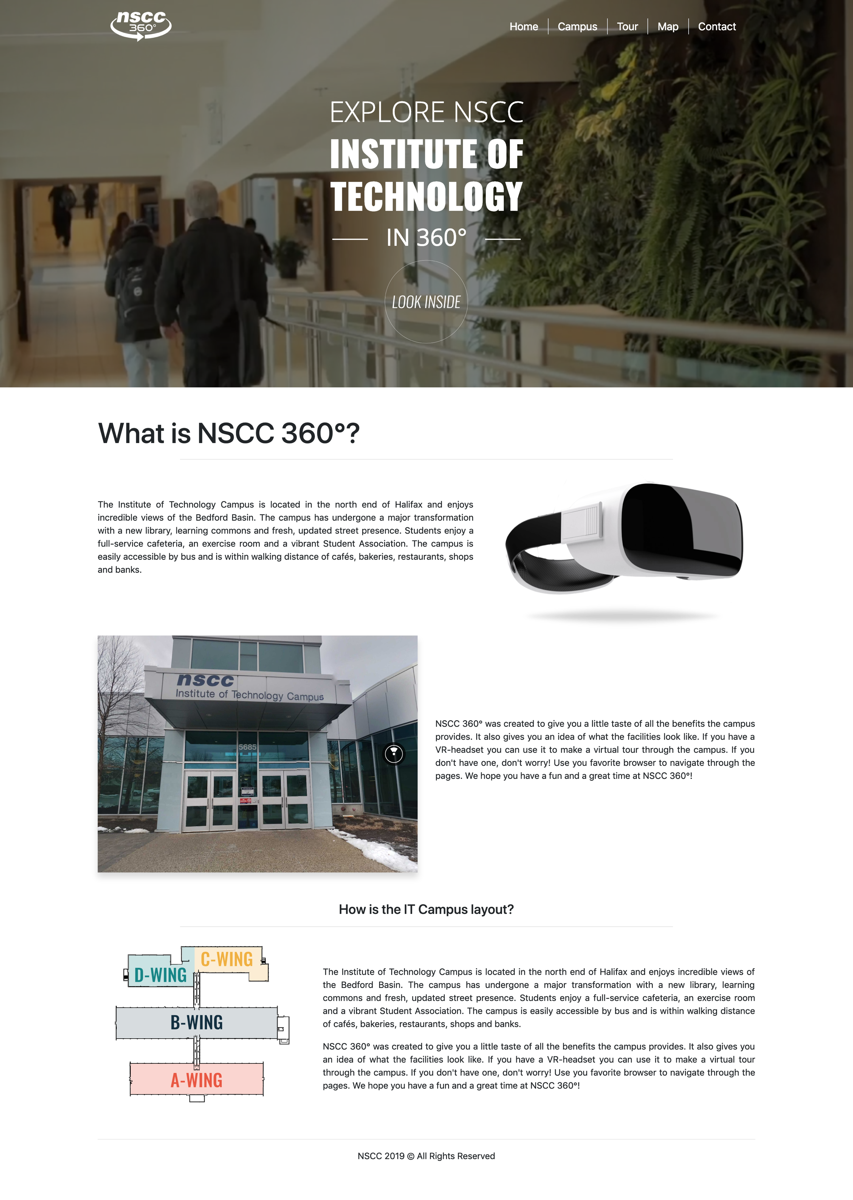

Home Page

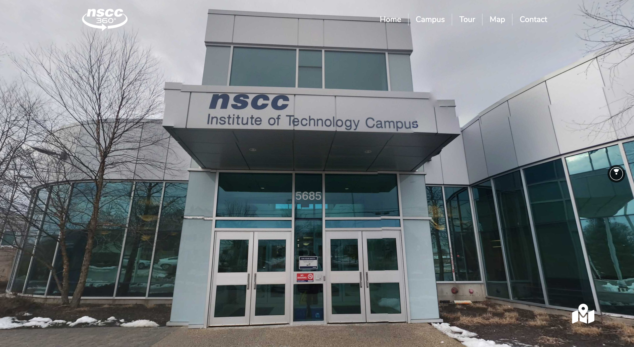

React 360 – Equirectangular Photos – Front Entrance

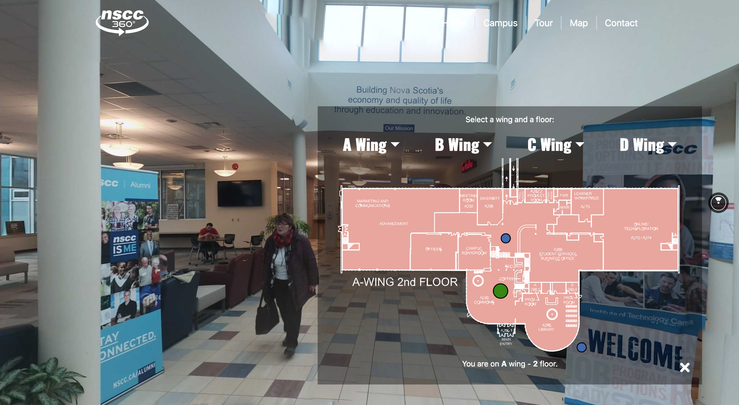

React 360 – Equirectangular Photos – Atrium